Ceil in Binary Search Tree.
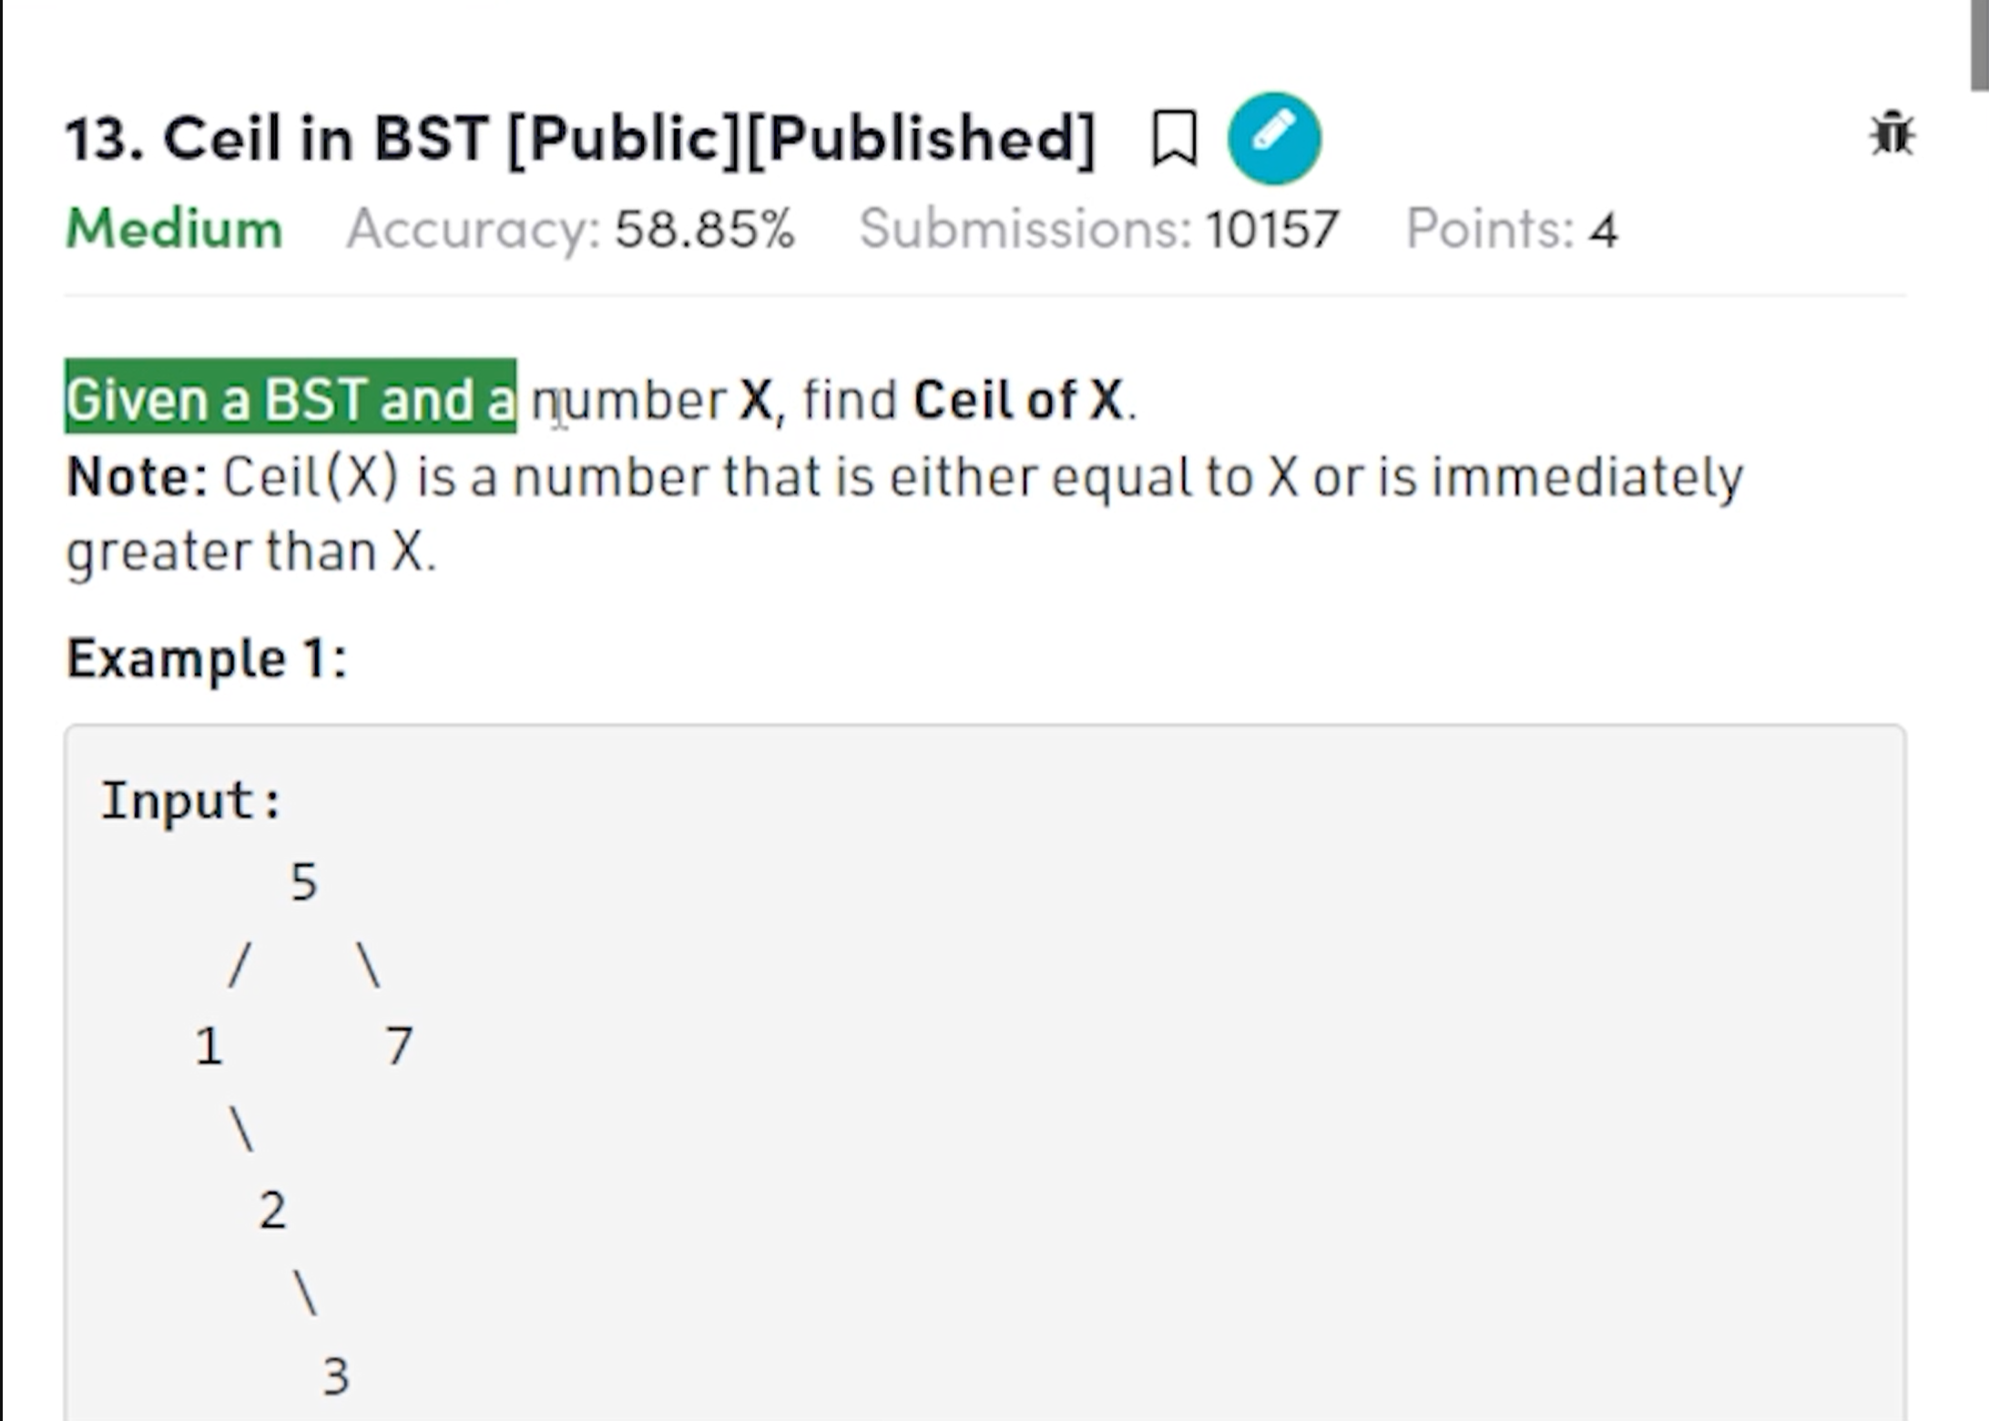
For 11 the ceil is the 14.
Ceil means the smallest value in greater than equal to key.


